Acts 170
Test 2
Summer 2013

- Here is the information about the data. It is in the excel data zip file where all the other files have been. It is titled AutoBI. LOSS is what we are using as the response variable.

I want all of your appropriate output, graphs, and answers to the questions in 1 document (which should be nice for me to read) and your code in another document.

You may not consult for help with your classmates. Any collusion will result in an immediate 0 for both parties. If you would like clarification on a question, ask me.

Even though I am not being specific on some questions, there are specific comments I am expecting to see often times. I am being general on purpose to see if you can recognize what is important and know what to say. I don’t want you to ramble forever on any question, but be thorough.

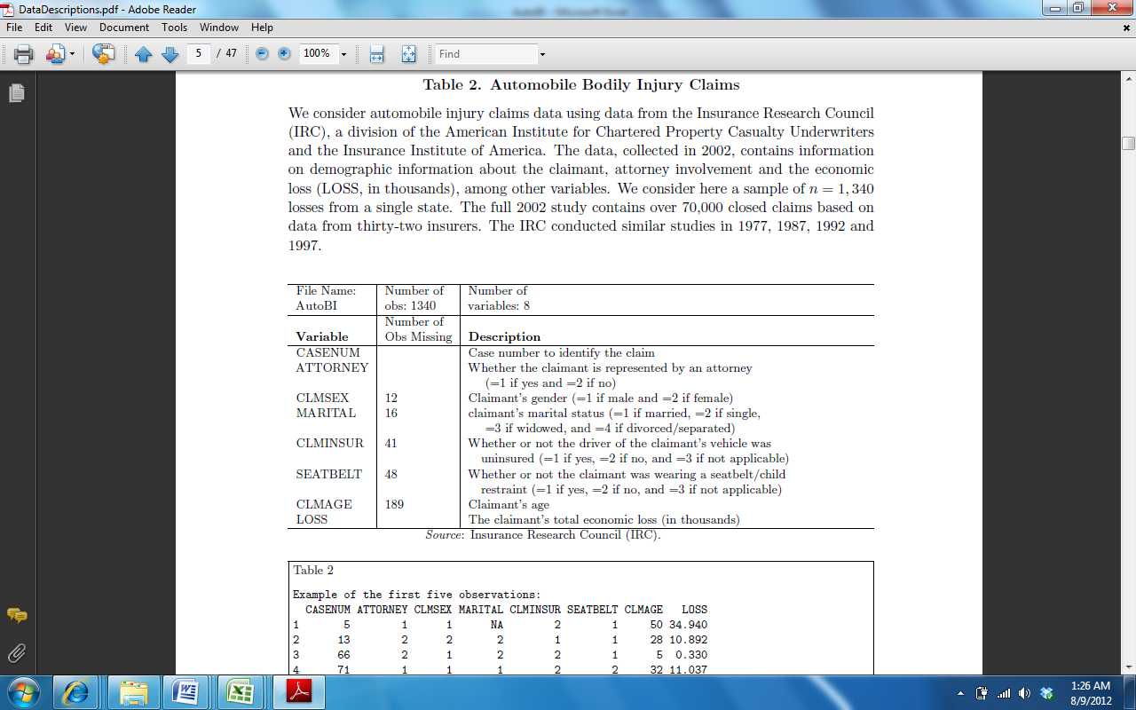
I want you to make a binary variable out of CLMINSUR so that it they answered yes they get a 1 and both other categories get a 0.
I want you to make a binary variable out of SEATBELT so that it they answered yes they get a 1 and both other categories get a 0.
- Run a regression on LOSS using your 2 binary variables above, ATTORNEY, CLMSEX, MARITAL, and CLMAGE as the explanatory variables. Are your 2 binary variables you created above significant? How do you know?
- Comment on the goodness of fit of the model.
- Interpret the coefficient for CLMSEX.
- Interpret the coefficient for when Marital =3.
- Rerun the regression in part a, adding an interaction term between CLMSEX and CLMAGE. Run a formal hypothesis test on this interaction term, with hypothesis statements, t-values and p-values, and decision.
- Predict the LOSS for someone who does have an attorney, is male, single, their vehicle was insured, they were not wearing a seatbelt, and they are 35.
- What is a 95% confidence interval for this predicted loss above? Interpret this interval.

- The dataset attached to the Test assignment on Blackboard, class info, is data that I collected from a previous statistics class with information on them. It includes their gender, gpa, stress level on a scale of 1 to 10 about taking the class, whether or not they can drive a car that is a stick shift, whether or not they intended to go to graduate school right after their bachelor’s degree, the row of the class that they were sitting in, the number of siblings they have, the type of laptop they owned, the number of countries besides the U.S. they had ever been to, the number of jobs they had the previous summer, the number of tattoos they had, the number of pets they had, and I added their HW3 score in the class and their Test3 score from the class.

- Run a regression model using Gender, GPA, GradSchl, ClassRow , siblings, countries, jobs, tattoos, pets, and HW3 to predict Test3. Then run a stepwise regression model (which we will call model B from now on) and compare these 2 models.
- Using the model you chose from stepwise regression, add square terms for every x variable that is currently in your model. Now determine whether these squared terms are jointly statistically significant. Do a formal hypothesis test using code and by hand.
- If you examine a new student who is Female, has a GPA of 3.23, does not want to attend grad school, sits in the second row, has 1 sibling, has been to 2 countries, has had 2 jobs, has 0 tattoos, 3 pets, a HW3 score of 85, predict her Test3 score using model B and find a 95% prediction interval for it. Interpret this interval.
- From model B, find a histogram of the standardized residuals and the leverages. Comment on these plots.
- Identify which of the observations under model B are outliers. It should be clear to me how you have determined these.
- Identify which of the observations under model B are high leverage points. It should be clear to me how you have determined these.
- Rerun model B, removing any points that are outliers. Note the changes that this has caused in the model.
- Using model B, find the correlation between the explanatory variables and find the variance inflation factors. Comment on these results appropriately.
- Run a one factor ANOVA model using laptop type to predict Test3. What do these results tell you about laptop choices?
- Comment on the goodness of fit from part (i).
- Interpret the coefficient of Dell. From the part (i) model.
- Now add the variables HW3 and GPA to your model in part (i). Comment on the changes in the coefficients of the Laptops between the 2 models. What could be the explanation for these changes?

